Interface Proposal: Useless Box
Jiyeon Kim
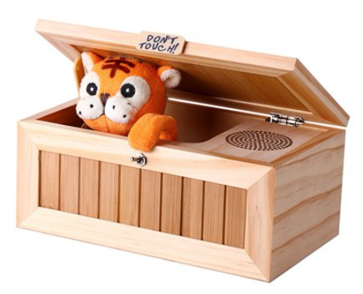

Tutorial/ Guide: How to Make Useless Box in Arduino

Link: https://youtu.be/cpdjQ0gheDQ

What is Useless Box?:
A useless machine is a device which has a function but no direct purpose. It may be intended to make a philosophical point, as an amusing engineering "hack", or as an intellectual joke. Devices which have no function or malfunction are not considered to be "useless machines".

The most well-known "useless machines" are those inspired by Marvin Minsky's design, in which the device's sole function is to switch itself off by operating its own "off" switch. More elaborate devices and novelty toys, having some obvious function or entertainment value, have been based on these simple "useless machines".

In my thought, the charm of the useless box is watching character’s reaction or program reaction when a person turns on the switch. This seems very modern interactive art. As an animation major student, interaction art and the animation of the programs give strong motivation to me.

- Founder of Useless machine, Marvin Minsky’s interview: https://youtu.be/C8kU3oZwVJA
- Marvin Minsky’s useless machine: https://youtu.be/d4cyu8jYceY (starts at 00:58).

My work plan of Useless machine with Processing

Since there are many heavy, cost materials requirements for arduino’s useless machine. I altered my idea and think, is it possible to generate useless machine using only processing.

Major key functions to create Processing useless box:
- Sound
- Animation (software: Adobe Photoshop, procreate
- Arduino Sensor ( 2nd Option )

- Sound:
- Minim
- Minim library
- Audio library
*Guideline/ learning resource: https://youtu.be/69IuP6uOmRA , https://youtu.be/LcX36OxgZgg

- Animation:
- PImage, Image
- FrameRate, For(int i), if (frame = ), if statement, int statement
- Array of image
- Translate
*Guideline/ learning resource: https://youtu.be/DPFJROWdkQ8 (array animation tutorial), https://youtu.be/3noMeuufLZY (animated SpritesSheet)

- Arduino Sensor as 2nd option:
- Motion sensor
- Arduino Switch button
- LED controller
*Guideline/ learning resource: https://youtu.be/58Ynhqmvzoc (push button, LED control)
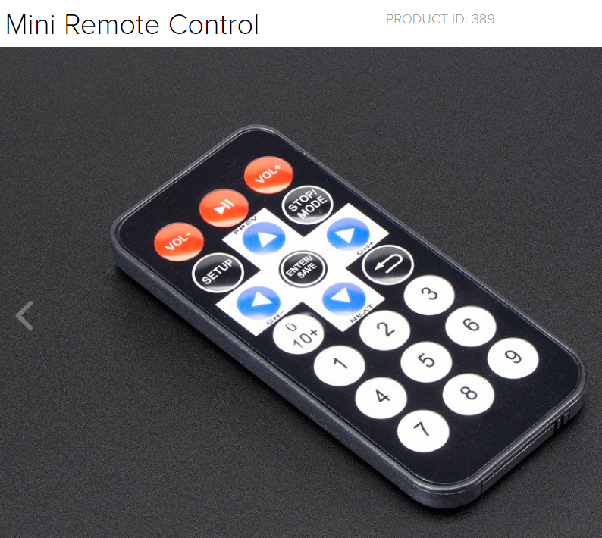
- Website: adafruit.com, $ 6.95 - adafruit.com , $ 4.95
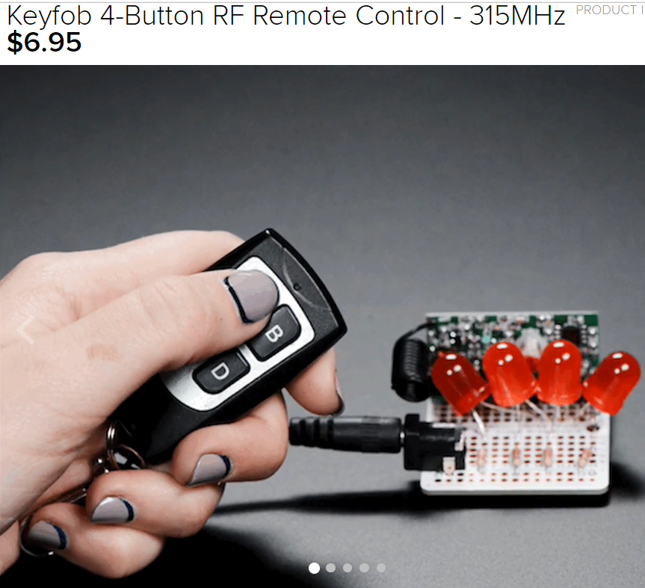

Display Idea:

- Computer (no keyboard) with full screened Processing
- Arduino switch in front of them

